脑的锻炼，强健和保持健康：

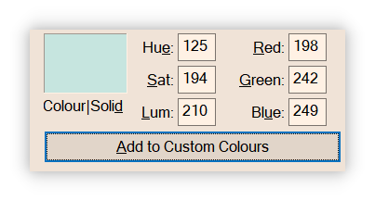

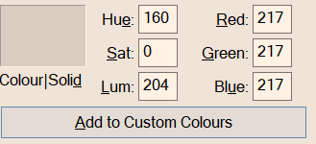



# 

# Output ensures quality. 输出，决定输入。

# 因为你事先知道output与往常不一样了，所以当面对同样的input，你自然会有不同的内化过程。

# 学科规律(Slogic)不一样：

# 理科的Slogic讲究deepth, 一长串的逻辑链，环环相扣

# 文科的Slogic讲究broad，逻辑链短，类似“归纳”

# 器术道

# 人性：冷漠 自私

# 你以为他真的在乎你吗？他是在利用你

# 真正长久舒适的关系靠的是共性和吸引，而不是一味地付出，你这是自我感动，你的付出被当作理所当然，越是付出越是被欺骗，被误解，越是得不到重视

# 你知道这叫什么吗? 犯贱

# 没有人关心你的遭遇，只关心你赚的比不比她多，

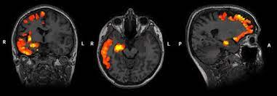

9 ways multitasking is killing your brain and productivity  
**4. Multitasking could make you dumber**

## ****9. Multitasking leads to stupid decision****

## ****6. Multitasking kills creativity****

# Reducing stress might [also] help,

# Stress and Other Things That Can Lead to Memory Loss and Brain Shrinkage

# Brain fog, memory loss, difficulty concentrating, brain shrinkage，*loss of neurons and the connections between them，Staying active and eating a balanced diet can lead to reduced risk of multiple conditions that can affect brain function. Protecting your head from injury is also important. Another very important factor is restful sleep.*

1. **Junk Food/ Fast Food.** lead to symptoms of depression and anxiety. These foods affect the production of dopamine – an important hormone that promotes happiness and an overall feeling of well-being. Dopamine also nurtures cognitive function, learning capacity, alertness, motivation and memory.
2. **Processed Proteins.** proteins are found mainly in meat products such as salami, sausages .Almost all processed foods contain chemicals, additives, artificial flavors, hormone that causes hyperactiveness both in adults and children.  they make it slow. which is somewhat similar to the shrinkage caused by Alzheimer’s disease. This shrinkage of the brain takes place due to the fact that trans fats slowly damage the arteries.
3. **Very salty foods.** affect your cognitive function and impair your ability to think. Otherwise salty foods affect your intelligence.
4. **Foods containing sugar and Artificial sweeteners** **.** prevent your good memory. affect your ability to learn. reduce the cognitive capacity,

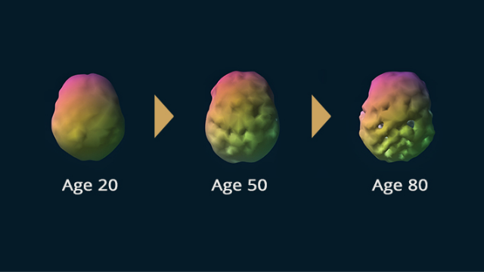  regional cerebral blood flow in the brain that is reduced in various disorders.  we can now track common disorders and behaviors that prematurely age the brain.

The study found that a number of brain disorders and behaviors predicted accelerated aging. especially schizophrenia, which showed an average of 4 years of premature aging, cannabis abuse (2.8 years of accelerated aging), bipolar disorder (1.6 years accelerated aging), ADHD (1.4 years accelerated aging) and alcohol abuse (0.6 years accelerated aging).

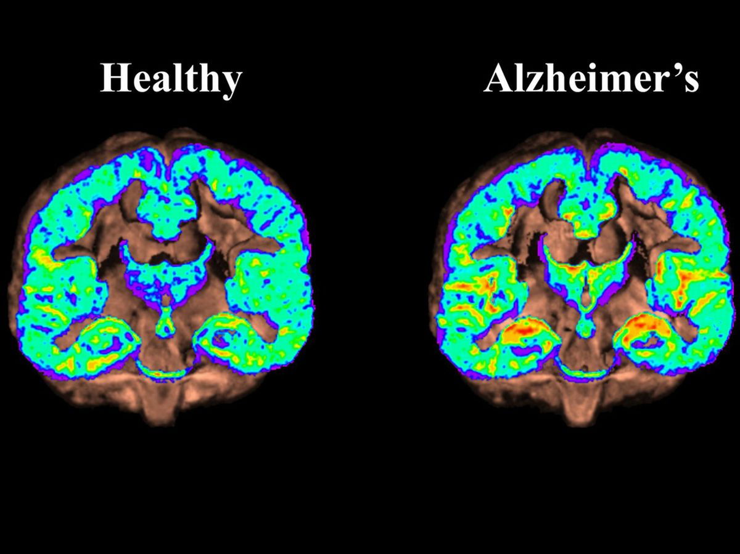

# SPECT Scan Reveal Link Between Obesity, Brain Blood Flow, and Alzheimer&#39;s - Diagnostic Imaging - New Zealand Online News Depression and Development - Children and Depression

**Evidence of Sleep-Dependent Brain Activity in Clearing Toxic Proteins and Preventing Alzheimer’s Disease**



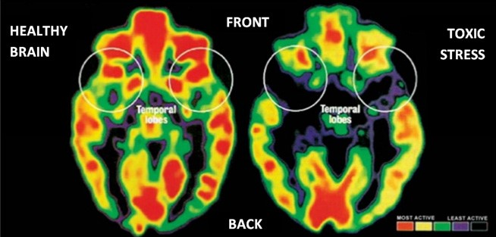

**Toxic Stress: A Threat to the Futures of Millions of Children**

# Reading, Technology and Brain Networks | Universal Design for Learning in HCPSS Secondary Student Presentation - ppt download Learning &amp; Reading Programs for APD, Dyslexia - Gemm Learning Effect of reading intervention and task difficulty on orthographic and phonological reading systems in the brain - ScienceDirect Tracking Adult Literacy Acquisition With Functional MRI: A Single‐Case Study - Braga - 2017 - Mind, Brain, and Education - Wiley Online Library Tracking Adult Literacy Acquisition With Functional MRI: A Single-Case Study

# the results indicate that adult plasticity can be sufficient to induce rapid changes in brain responses to written words and faces in an unschooled and illiterate adult.

# Processing of a spoken narrative in the human brain is shaped by family cultural background | bioRxiv Engage their Brains Multisensory Activities to Promote Reading

# We are what we think, what we eat, what we habit.